A REPORT

ON

**DESIGN OF A MIXED REALITY SYSTEM FOR ARCHAEOLOGY**

BY

AKSHAT SINGH 2019A7PS0074P COMPUTER SCIENCE

**DESIGN ORIENTED PROJECT**

Under the guidance of

**MR. MUKESH KUMAR ROHIL**

**BIRLA INSTITUTE OF TECHNOLOGY & SCIENCE, PILANI**

**DECEMBER 2021**



**ACKNOWLEDGEMENTS**

I would like to thank AUGSD for providing me with this opportunity to be able to work under seasoned and esteemed professors of BITS Pilani and gain immeasurable knowledge and experience from the same.

I would like to express my very great gratitude to Mr. Mukesh Kumar Rohil for his valuable guidance and constructive suggestions during the planning as well as the development of this project. His willingness to give his time so generously has been very much appreciated.

Many thanks go to the Head of Department, Mr Sudeept Mohan who has invested his full effort in guiding the team in achieving the goal. I have to appreciate the guidance given by other supervisors as well as the panels. Their inputs have has improved our technical and social skills.

Last but not the least, I extend my thanks to my friend and fellow workmate Krish Vora for being incredibly supportive and helpful. His valuable inputs have been immensely helpful in the project.

**ABSTRACT**

**BIRLA INSTITUTE OF TECHNOLOGY AND SCIENCE PILANI (RAJASTHAN)**

**Dept of Computer Science and Information Systems**

**Duration:** 1 semester **Date of Start:** 21st August 2021

**Date of Submission:** 5th December 2021

**Title of the Project:** DESIGN OF A MIXED REALITY SYSTEM FOR ARCHAEOLOGY

**ID No./Name:**  2019A7PS0074P / Akshat Singh

**Discipline of the student:** Computer Science

**Name of the Faculty:** Mr. Mukesh Kumar Rohil

**Key Words:** Computer Science, Archaeology, Mixed Reality, Computer Vision, 3d modelling, Unity, Reconstruction

**Project Areas:** Augmented/Virtual Reality

**Abstract:** Digitally reconstruct a damaged artifact/structure. Involves 3d modelling and augmented reality projection.

**TABLE OF CONTENTS**

1. Title Page
2. Acknowledgements
3. Abstract Sheet
4. Table of Contents
5. Augmented Reality
6. Applications
7. AR in archaeology
8. Introduction
9. Problem Statement
10. Motivation
11. Workflow
12. Conclusions
13. References
14. Appendix

**AUGMENTED REALITY**

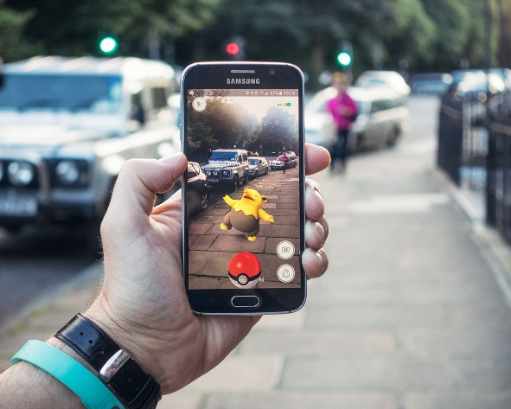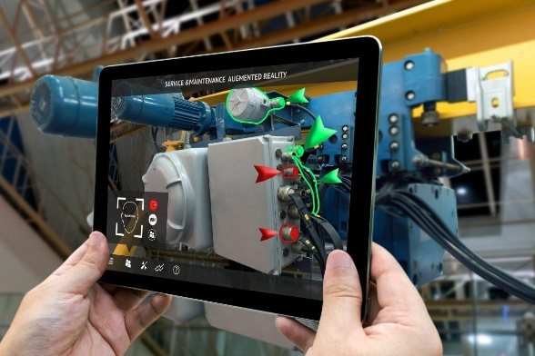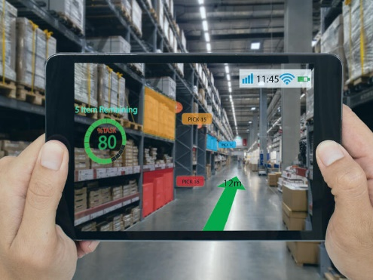**Augmented reality** (**AR**) is an interactive experience of a real-world environment where the objects that reside in the real world are enhanced by computer-generated perceptual information, sometimes across multiple sensory modalities, including visual, auditory, haptic, somatosensory and olfactory. AR can be defined as a system that incorporates three basic features: a combination of real and virtual worlds, real-time interaction, and accurate 3D registration of virtual and real objects. The overlaid sensory information can be constructive (i.e. additive to the natural environment), or destructive (i.e. masking of the natural environment). This experience is seamlessly interwoven with the physical world such that it is perceived as an immersive aspect of the real environment. [[1]](https://en.wikipedia.org/wiki/Augmented_reality) In this way, augmented reality alters one's ongoing perception of a real-world environment, whereas virtual reality completely replaces the user's real-world environment with a simulated one. Augmented reality is used to enhance natural environments or situations and offer perceptually enriched experiences. With the help of advanced AR technologies (e.g. adding computer vision, incorporating AR cameras into smartphone applications and object recognition) the information about the surrounding real world of the user becomes interactive and digitally manipulated. Information about the environment and its objects is overlaid on the real world. This information can be virtual. Augmented Reality is any experience which is artificial and which adds to the already existing reality.

### Hardware

[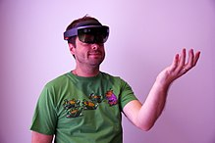](https://en.wikipedia.org/wiki/File:MicrosoftHoloLensBloomGesture.JPG)Hardware components for augmented reality are: a processor, display, sensors and input devices. Modern mobile computing devices like smartphones and tablet computers contain these elements, which often include a camera and microelectromechanical systems (MEMS) sensors such as an accelerometer, GPS, and solid-state compass, making them suitable AR platforms.

#### Display

Various technologies are used in augmented reality rendering, including optical projection systems, monitors, handheld devices, and display systems, which are worn on the human body. A head-mounted display (HMD) is a display device worn on the forehead, such as a harness or helmet-mounted. HMDs place images of both the physical world and virtual objects over the user's field of view.

##### Eyeglasses

AR displays can be rendered on devices resembling eyeglasses. Versions include eyewear that employs cameras to intercept the real-world view and re-display its augmented view through the eyepieces and devices in which the AR imagery is projected through or reflected off the surfaces of the eyewear lens pieces.

###### HUD

[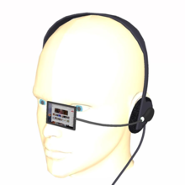](https://en.wikipedia.org/wiki/File:Headset_computer.png)A head-up display (HUD) is a transparent display that presents data without requiring users to look away from their usual viewpoints. A precursor technology to augmented reality, heads-up displays were first developed for pilots in the 1950s, projecting simple flight data into their line of sight, thereby enabling them to keep their "heads up" and not look down at the instruments. Near-eye augmented reality devices can be used as portable head-up displays as they can show data, information, and images while the user views the real world. Many definitions of augmented reality only define it as overlaying the information. This is basically what a head-up display does; however, practically speaking, augmented reality is expected to include registration and tracking between the superimposed perceptions, sensations, information, data, and images and some portion of the real world.

##### Contact lenses

Contact lenses that display AR imaging are in development. These bionic contact lenses might contain the elements for display embedded into the lens including integrated circuitry, LEDs and an antenna for wireless communication. The first contact lens display was intended to work in combination with AR spectacles, but the project was abandoned. Another version of contact lenses, in development for the U.S. military, is designed to function with AR spectacles, allowing soldiers to focus on close-to-the-eye AR images on the spectacles and distant real world objects at the same time.

**APPLICATIONS OF AUGMENTED REALITY**

### Architecture

AR can aid in visualizing building projects. Computer-generated images of a structure can be superimposed onto a real-life local view of a property before the physical building is constructed there. AR can also be employed within an architect's workspace, rendering animated 3D visualizations of their 2D drawings. Architecture sight-seeing can be enhanced with AR applications, allowing users viewing a building's exterior to virtually see through its walls, viewing its interior objects and layout.

### STEM education

In educational settings, AR has been used to complement a standard curriculum. Text, graphics, video, and audio may be superimposed into a student's real-time environment. Textbooks, flashcards and other educational reading material may contain embedded "markers" or triggers that, when scanned by an AR device, produced supplementary information to the student rendered in a multimedia format.

First, AR technologies help learners engage in authentic exploration in the real world, and virtual objects such as texts, videos, and pictures are supplementary elements for learners to conduct investigations of the real-world surroundings. As AR evolves, students can participate interactively and interact with knowledge more authentically. Instead of remaining passive recipients, students can become active learners, able to interact with their learning environment.

### Commerce

AR is used to integrate print and video marketing. Printed marketing material can be designed with certain "trigger" images that, when scanned by an AR-enabled device using image recognition, activate a video version of the promotional material.

AR can enhance product previews such as allowing a customer to view what's inside a product's packaging without opening it. AR can also be used as an aid in selecting products from a catalogue or through a kiosk. Scanned images of products can activate views of additional content such as customization options and additional images of the product in its use.

### Human Computer Interaction

Human Computer Interaction is an interdisciplinary area of computing that deals with design and implementation of systems that interact with people. Researchers in HCI come from a number of disciplines, including computer science, engineering, design, human factor, and social science, with a shared goal to solve problems in the design and the use of technology so that it can be used more easily, effectively, efficiently, safely, and with satisfaction.

**USE OF AR IN ARCHAEOLOGY**

The artistic or historical value of a structure, such as a monument, a mosaic, a painting or, generally speaking, an artifact arises from the novelty and the development it represents in a particular field and for a specific time of human activity. [[2]](https://core.ac.uk/download/pdf/53843688.pdf) The more faithfully the structure preserves its original status, the greater its artistic and historical value is. But preserving a structure cannot always be possible (for traumatic events as wars can occur). In such a frame, the current technology furnishes a fundamental help for reconstruction/restoration purposes to bring back a structure to its original historical value and condition.

The idea is to realize a virtual reconstruction/restoration before materially acting on the the structure itself, using 3D construction. A means of digitalizing the physical world, 3D reconstruction is often divided into two types, scene and object reconstructions, both of which are essential building blocks of various applications in robotics, self-driving vehicle-making and other forms of manufacturing, cultural-heritage preservation, digital museums, and mixed reality, among other fields. These reconstruction techniques have been developed with substantial effort and can be conducted by either traditional surveying or novel 3D modeling systems.

**INTRODUCTION**

Restoration of ancient artifacts is an important step in the process of studying its history. In this world that’s transitioning swiftly to a digital environment, we can make use of available technological tools to our benefit. Augmented Reality is one such field which can accomplish this task efficiently. Using AR, we can attempt to recreate history the way we want it to. Reconstructing structures, replaying scenarios, digitally repairing artifacts are some applications of AR in the field of archaeology.

This project focuses on using AR tools such as Unity, Vuphoria, OpenCV and 3d modelling applications like Blender, Meshroom, etc to make applications that can add 3d models to a real time element. In this project, we plan to achieve reconstruction and restoration of damaged artifacts, statues etc.

**PROBLEM STATEMENT**

Any monument, structure, or artifact can be reconstructed as its digital simulation, and the user can see it as if it was right there in front of him. Using a tracked video-see-through Head Worn Device (HWD) and dynamic modeling of the real and virtual world, it is possible to insert virtual characters into various buildings or sites and enact a real-time storytelling scenario. This would help the user experience the events related to the site as they happened and provide them with unique perspectives and feelings of presence and immersion.

**MOTIVATION**

AR can be successfully used for restoration and reconstruction purposes, so it can play an *active role*, rather than be utilized for mere tutorial reasons, so to be confined in a *passive part*. [[4]](https://www.sciencedirect.com/science/article/pii/S0926580512001690)

This is for several reasons:

* restoration and/or reconstruction time can be reduced;
* the costs for restoration and/or reconstruction can be reduced: workforce and machinery are utilized only at the absolute final step, so even the energy consumption is saved;
* some potential breakages or risk of destruction of the archaeological, often fragile but valuable, artifacts to be restored and/or reconstructed can be avoided;
* some potential abrasions/changes in colors of the artifacts can be avoided;
* it is possible to establish forms and dimensions of the parts which are eventually incomplete so to rebuild the relic exactly;
* it is possible to assemble the artifacts without damaging their remains and even cause damages in the excavation site where the artifact was found;
* it is possible to preview the possibilities of assembling more efficiently, reducing errors and the time spent in those tasks;
* the 3D scanning procedure is also helpful to create a database, for cataloging reasons, for tourism promotion aims, for comparison studies, etc.;
* in cases where the structural stability of a monument is not in danger, nonintrusive visual reconstructions should be preferred to physical reconstruction;

and so on.

**WORKFLOW**

* The work is done in several steps. The first step involves identifying the structure to be reconstructed in the project and analysing it. We need to take several pictures of it from all angles and directions. An example of that is shown using this Rubik’s cube.

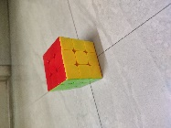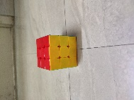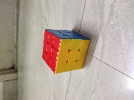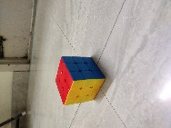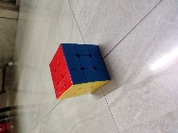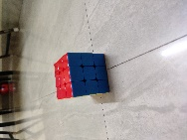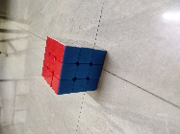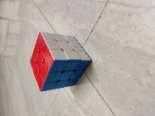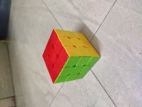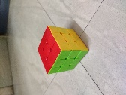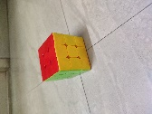

Here we see the cube from all sides and angles – top, front, side.

Next step involves processing these pictures in a software. We have presently used Meshroom which uses depth and mesh analysis to generate 3D models of general elements. It creates a mesh of pixels which acts as a base for the actual texture.

We input this collection of photos into Meshroom and begin the process. This is what the processing looks like –

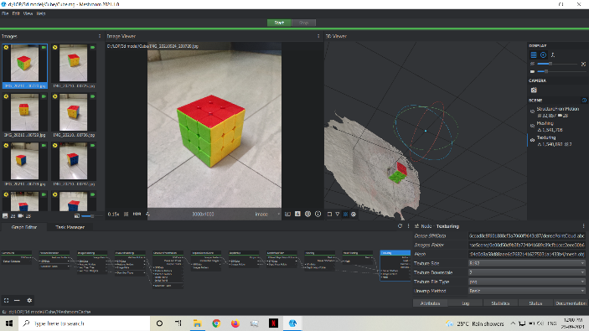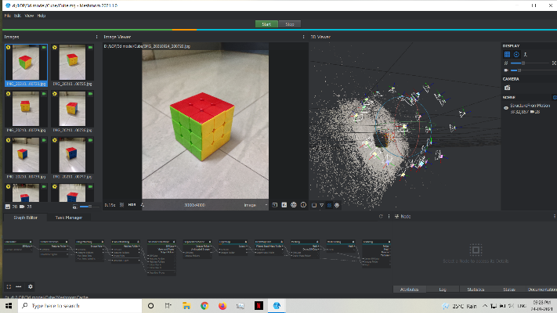

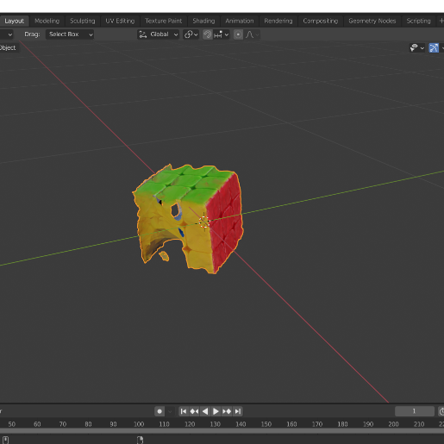Once the processing is done, which itself is a time-consuming process we get an output mesh of the element. This mesh has to be then imported into Blender and further worked upon. Blender is a 3d modelling software with several formatting options to refine our model. Hence we use it to clean up our mesh and give a solid model of it. Once the refining in blender is complete, our model is almost ready –

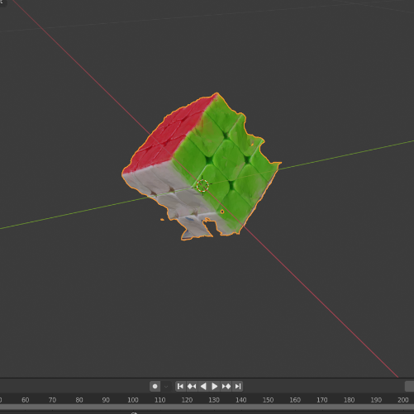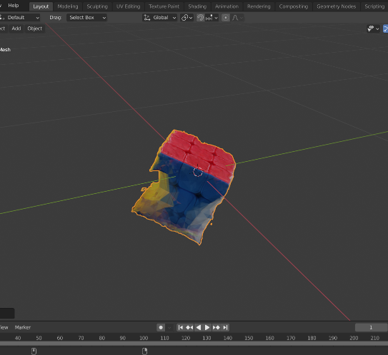

This model is application-ready and can directly be exported to Unity for implementation.

* Another aspect of this project is application development. Here we use technologies like Unity and Vuphoria to develop AR-based applications. The 3d model obtained in the last process is used in Unity as an asset. It can be implemented into software applications like any other inbuilt asset.

Here We try to implement 3d model of a statue bust in our application. The task of the application is to detect a target object and place the model upon it. The target used for this purpose is a diary –

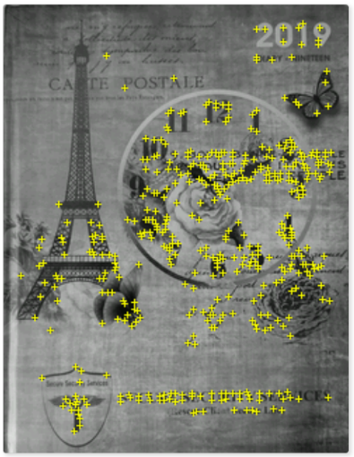

This target is added to the Vuphoria database and Unity makes use of that. When the application detects the target, it places our model on top of it as shown below

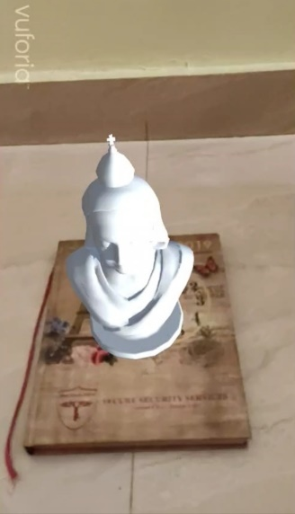

**Brick implementation: -**

We follow this approach and try to implement this technique on a more project-related object.

In the main application, red soil brick is being used. We begin the process by developing a 3d model of the brick in Meshroom, enhancing in Blender and getting it ready-to-use in Unity.

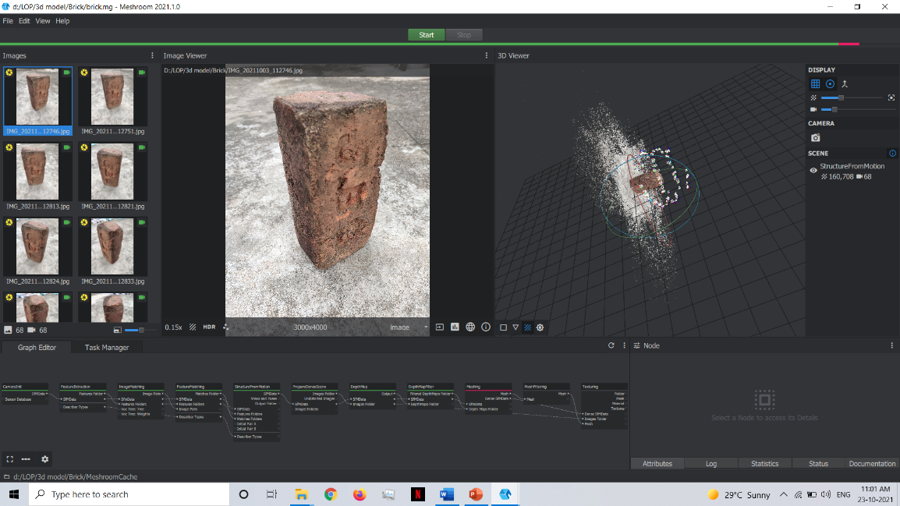

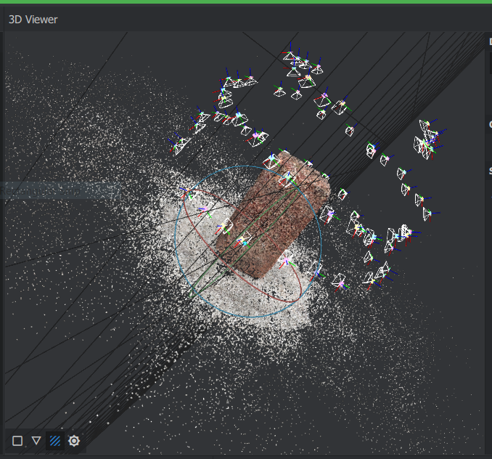

Next, we try to use this developed model as an overlay in our application. Firstly, we need an object target for overlaying upon. Our object target in this case will be a broken brick, upon which we will impose our fully-made brick model. Since our target this time is an 3d object, we need a 3d object scanner.

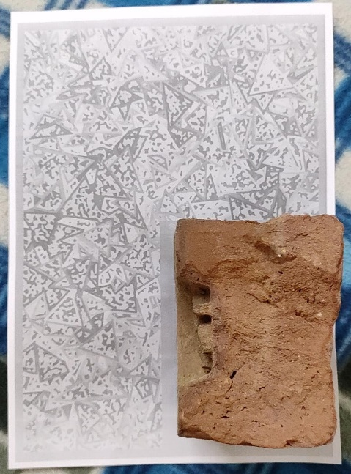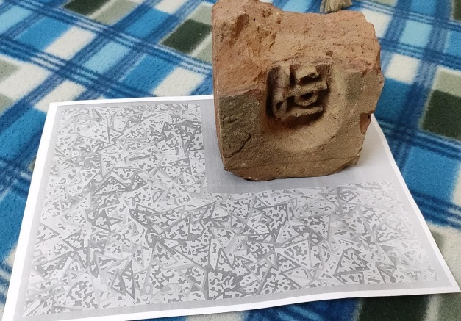Scanning of 3d objects using Vuforia’s own Object Scanner. The procedure involves keeping the object that needs to be scanned on printed target paper. This paper provides the coordinates and offset for the scanner to detect object and scan it.

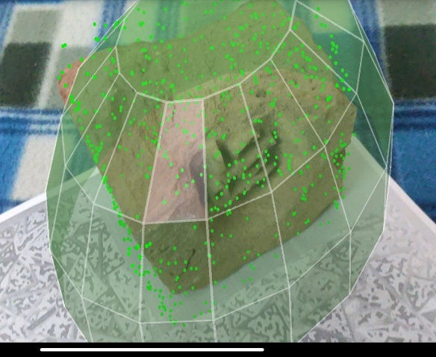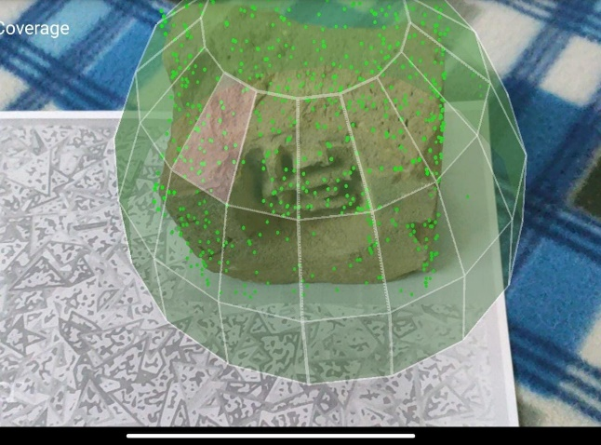We then use the scanner application to capture the object. It detects identification points and creates a mesh-like model of these points.

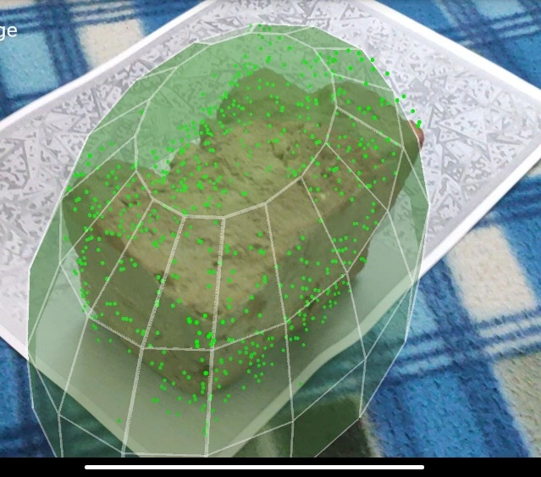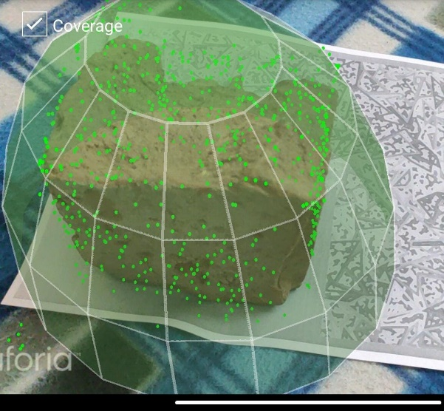

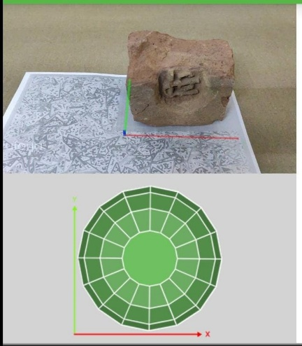Upon scanning the object, it can also be tested to see if a valid 3d object target has been created.

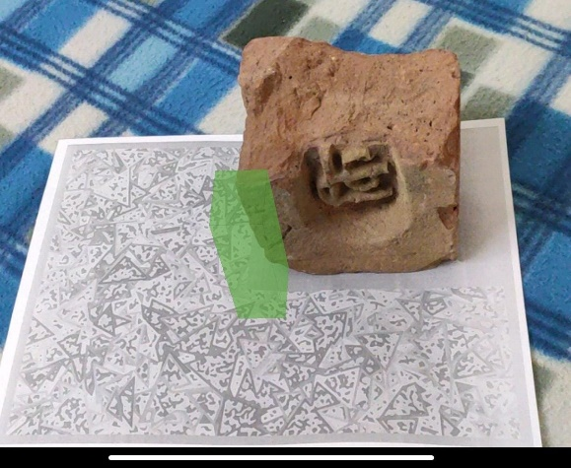

Now we have our object target ready. Our AR camera detects this target and places our developed 3d model on it. Aligning with our project, The AR app detects an eroded/broken brick and superimposes a complete a 3d brick model on it. Hence it seems like the incomplete structure is completed.

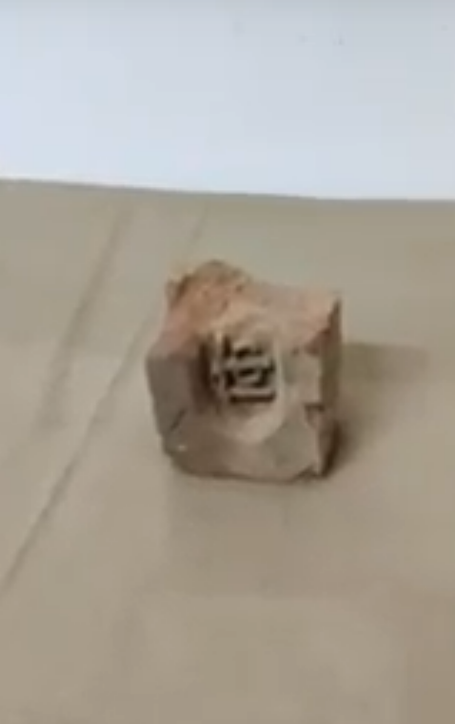 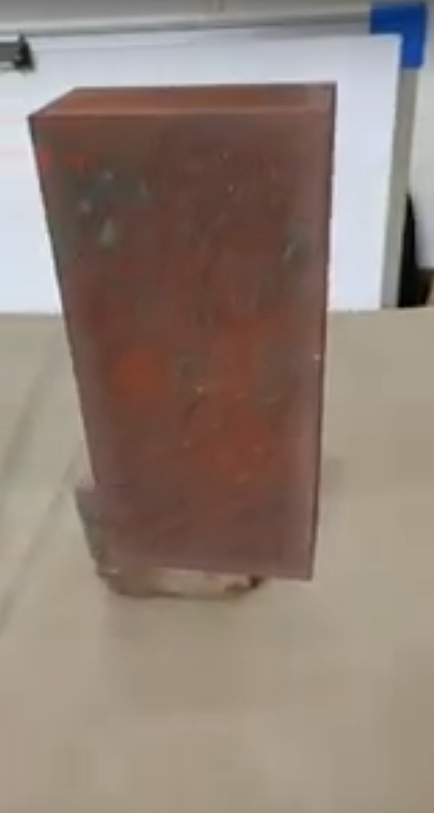 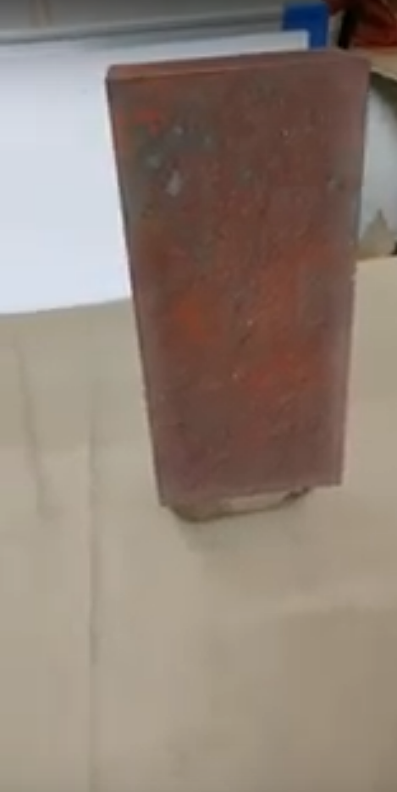

**CONCLUSION**

Throughout the entire workflow, via multiple trials and errors, failures and successes, I reached many of the intended final application outcomes. There are still a few things that could be further optimized. For example, functionalities to zoom and rotate the object could not be added. However, since this being a fundamental feature, it is my hope that there could be a way to achieve it, which could be mentioned in the documentation or might require advanced C# knowledge.

Also, going through the process of learning modelling in Blender was immensely challenging. Since I found it difficult to master the software in the span of a few weeks, I decided to follow step by step tutorials so that I could generate usable output while learning the software itself. Such an approach not only made learning it easier, but also rewarding and productive. Thus, in spite of reaching and completing many of my intended goals of designing a mixed reality system for archaeology, it would be hard not to accept that designing the АR applications proved to be an extremely challenging, but rewarding process. Seeing my work evolve, with so many real world applications, instilled in me a sense of exuberance, as it was a chance for my work to make a change to society. I would like to finally thank Prof Mukesh Kumar Rohil for this immensely valuable opportunity, to work on applications and learn the relevant skills to create a positive impact on the society through my work.

**REFERENCES**

[1] – <https://en.wikipedia.org/wiki/Augmented_reality>

[2] – <https://core.ac.uk/download/pdf/53843688.pdf>

[3] – <https://www.vrvis.at/en/publications/pdfs/PB-VRVis-2007-006.pdf>

[4] – <https://www.sciencedirect.com/science/article/pii/S0926580512001690>

**APPENDIX**

Finished application – <https://drive.google.com/file/d/18RpbVfh-p0qGj21n2c8EQoYXYVzl0Qf5/view?usp=sharing>

Statue Model demo – <https://drive.google.com/file/d/1hRk27T4dPOdb6A1EWWTXenFEI0RAYj-W/view?usp=sharing>

Brick demo – <https://drive.google.com/file/d/19GlMo6WEtH-8GYzELJGLMK6J7BNrcycH/view?usp=sharing>